Kerman Space Systems

R-3 Series of Carrier Rocket

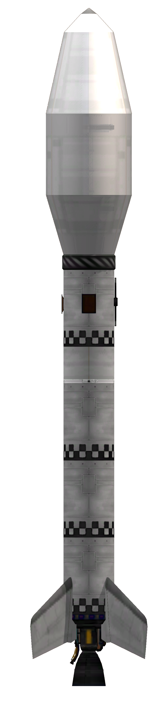
Operator’s Manual
TABLE OF CONTENTS

R-3 family description
The R-3 rockets are 2 stage rockets designed as a payload carrier for ground to low Kerbin orbit. These rockets are designed to deliver a payload of up to 3.2 tonnes to an 80 KM circular orbit.
The rocket comes with a standard payload section, simplifying performance calculations. The most relevant parameter for performance calculation for a specific fairing type is payload mass.

Vehicle coordinate data
The launch vehicle coordinate system is comprised of three axes. Using these axes, directions can be unambiguously referenced in this manual.
The X axis runs along the body of the rocket. It is also known as the roll axis. A clockwise movement, as seen into the vehicle’s nozzles is defined as a “right roll”, while the opposite roll is defined as a “left roll”. These movements correspond to the input controls and the response of the navball.
The two remaining axes delimit the sides of the rocket. The Z axis defines the left and right sides. Rotating over the Y axis, causing the nose to point to the +Z direction is called a “right yaw” while the opposite movement is a “left yaw”. Rotating over the Z axis to point the nose to the +Y direction is a “pitch up” maneuver, while the opposite is a “pitch down”. These movements correspond to the yaw and pitch movements caused by acting on the respective controls and the corresponding navball response.
Additionally, the +Z side is called the “east” side, the -Z side is called “west” and the +Y and -Y are called “south” and “north” respectively. These shorthand definitions correspond to the cardinal directions faced by each side, when sitting on the pad waiting to launch, and is used to identify each upper stage hardpoint.
The +Z and -Z sides are also called the “right” and “left” side during the autopilot program descriptions.
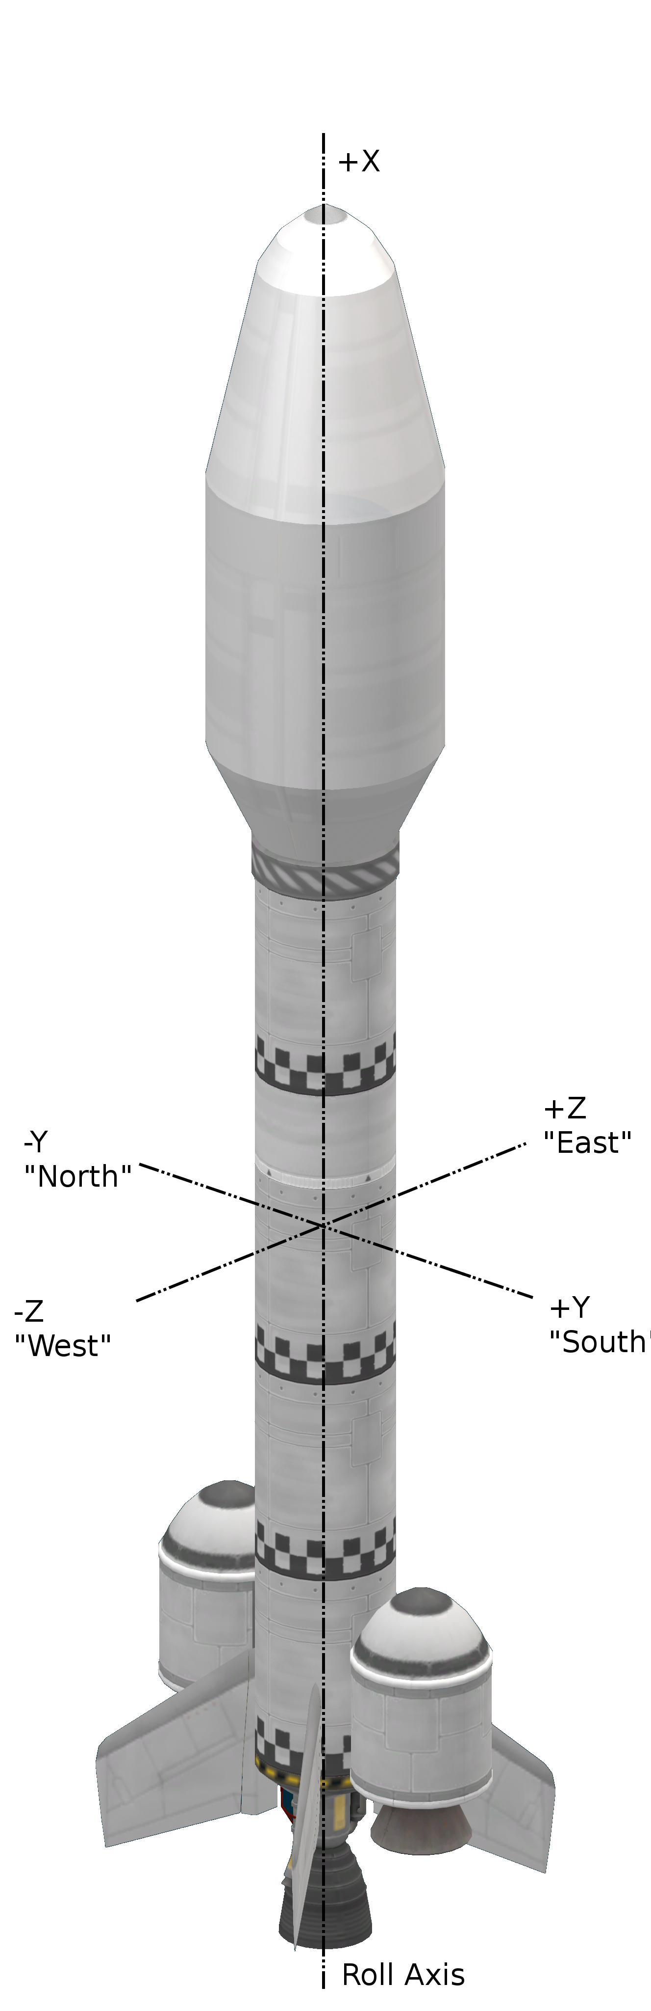

R-3 series ID codes
R-3 rockets are identified by the following alphanumerical code.

R3-(400,800,1200,1200B,1200L)-(F,C,S,D)(1,2,3,4,5)-(N,O,J,H)(0,1,2)(0,1)(N,O,P,Q)(0,1,2)(X,R)

These codes describe the features of each specific rocket type and should be interpreted in the following way.

R3-(Type)-(Payload Section)-(Avionics)

The R3 string defines the base rocket family. Strings other than R3 represent different rocket families, specified in other documents. This identifying string is left constant for all members of this launch vehicle family.
The type defines which specific member of the R-3 family is being described. There are 5 members of the R-3 family.

Rocket type code | Description
400 | Ultra short launch vehicle, for very light payloads
800 | Shorter launch vehicle
1200 | Baseline launch vehicle
1200B | Boosted 1200 model, two solid fueled boosters
1200L | Booster 1200 model, two liquid fueled boosters

The payload definition is a two letter code describing the arrangement of payload bay and fairing type. The payload bay definition comes first, followed by a fairing definition.

Bay code | Description
F | Payload affixed to fairing base, integral to upper stage
C | Capsule service module, no avionics bay
S | Single payload with avionics bay
D | Dual payloads with avionics bay

The fairing definition is shown below.
Fairing code | Description
1 | Kerman Space Systems fairing type A1
2 | Kerman Space Systems fairing type A2
3 | Kerman Space Systems fairing type A3
4 | Kerman Space Systems fairing type B1
5 | Kerman Space Systems fairing type B2

Types 1 to 3 fairings are used for general cargo, while fairing types 4 (B1) and 5 (B2) are used for manned capsules. Rocket type C4 has been designed with the AOC-3 capsule in mind, while type C5 is suited for launching the AOC-2 capsule. See their respective manuals for details.

Immediately after the payload section definition comes the avionics description code. This code describes the launch vehicle’s avionics. Each letter describes a particular system, and has several variants described in the table below. Avionics are mounted in the avionics bay inside the fairing or in 4 hardpoints, radially, connected to the upper stage fuel tank.
System | Code | Definition
On board computer | N | No OBC. Guidance depends on payload computer.
On board computer | J | MechJeb2 AR202 case in west upper stage hardpoint.
On board computer | O | Probodobodyne OKTO in payload bay.
On board computer | H | Probodobodyne HECS in payload bay.
Stabilization | 0 | No reaction wheels, except as provided by OBC.
Stabilization | 1 | Small reaction wheel in avionics bay.
Stabilization | 2 | Advanced Inline Stabilizer in avionics bay.
Communications | 0 | Payload communications only.
Communications | 1 | Communotron-16S in east upper stage hardpoint.
Power generation | N | No power supply, power provided only by batteries.
Power generation | O | 2 OX-STAT solar panels radially attached to north/south sides.
Power generation | P | 1 OX-STAT solar panel radially attached to west side.
Power generation | Q | Model O and P panels.
Power storage | 0 | On board computer and payload batteries only
Power storage | 1 | Z-200 battery bank in avionics bay
Power storage | 2 | Z-1K battery bank in avionics bay
Reusability | X | Expendable.
Reusability | R | Single MK16 parachute in avionics bay.

R-3 rocket assembly
R-3 rockets should normally be taken from a template, resorting to manual assembly only if a template is not available. The use of a template ensures consistency in performance and physical characteristics.
After manual assembly and testing of an R-3 model, we recommend saving the result as a template.
Boosted variants should be extensively tested to ensure proper booster aerodynamic characteristics during ejection.

Lower stage

Sustainer core assembly
Take a LV-T30 “Reliant” liquid fueled engine and place in the VAB building. Ensure that it is set to full thrust.
Take the necessary number of “dark” themed FL-T400 fuel tanks (1 for the R-3-400, 2 for the R-3-800 and 3 for the R-3-1200) and stack them axially above the engine, one above the next. Other types of fuel tanks are not recommended, as using the same tank type for all variants simplifies the conversion between models and other tank models may also lack important markings used in as reference during assembly.
Take a TD-12 decoupler and stack axially above the topmost fuel tank.

Sustainer fin installation
Fin assembly should be done using 4-way radial symmetry. The installation should be done simultaneously on all 4 fins, and manual installation (one at a time) should not be used.
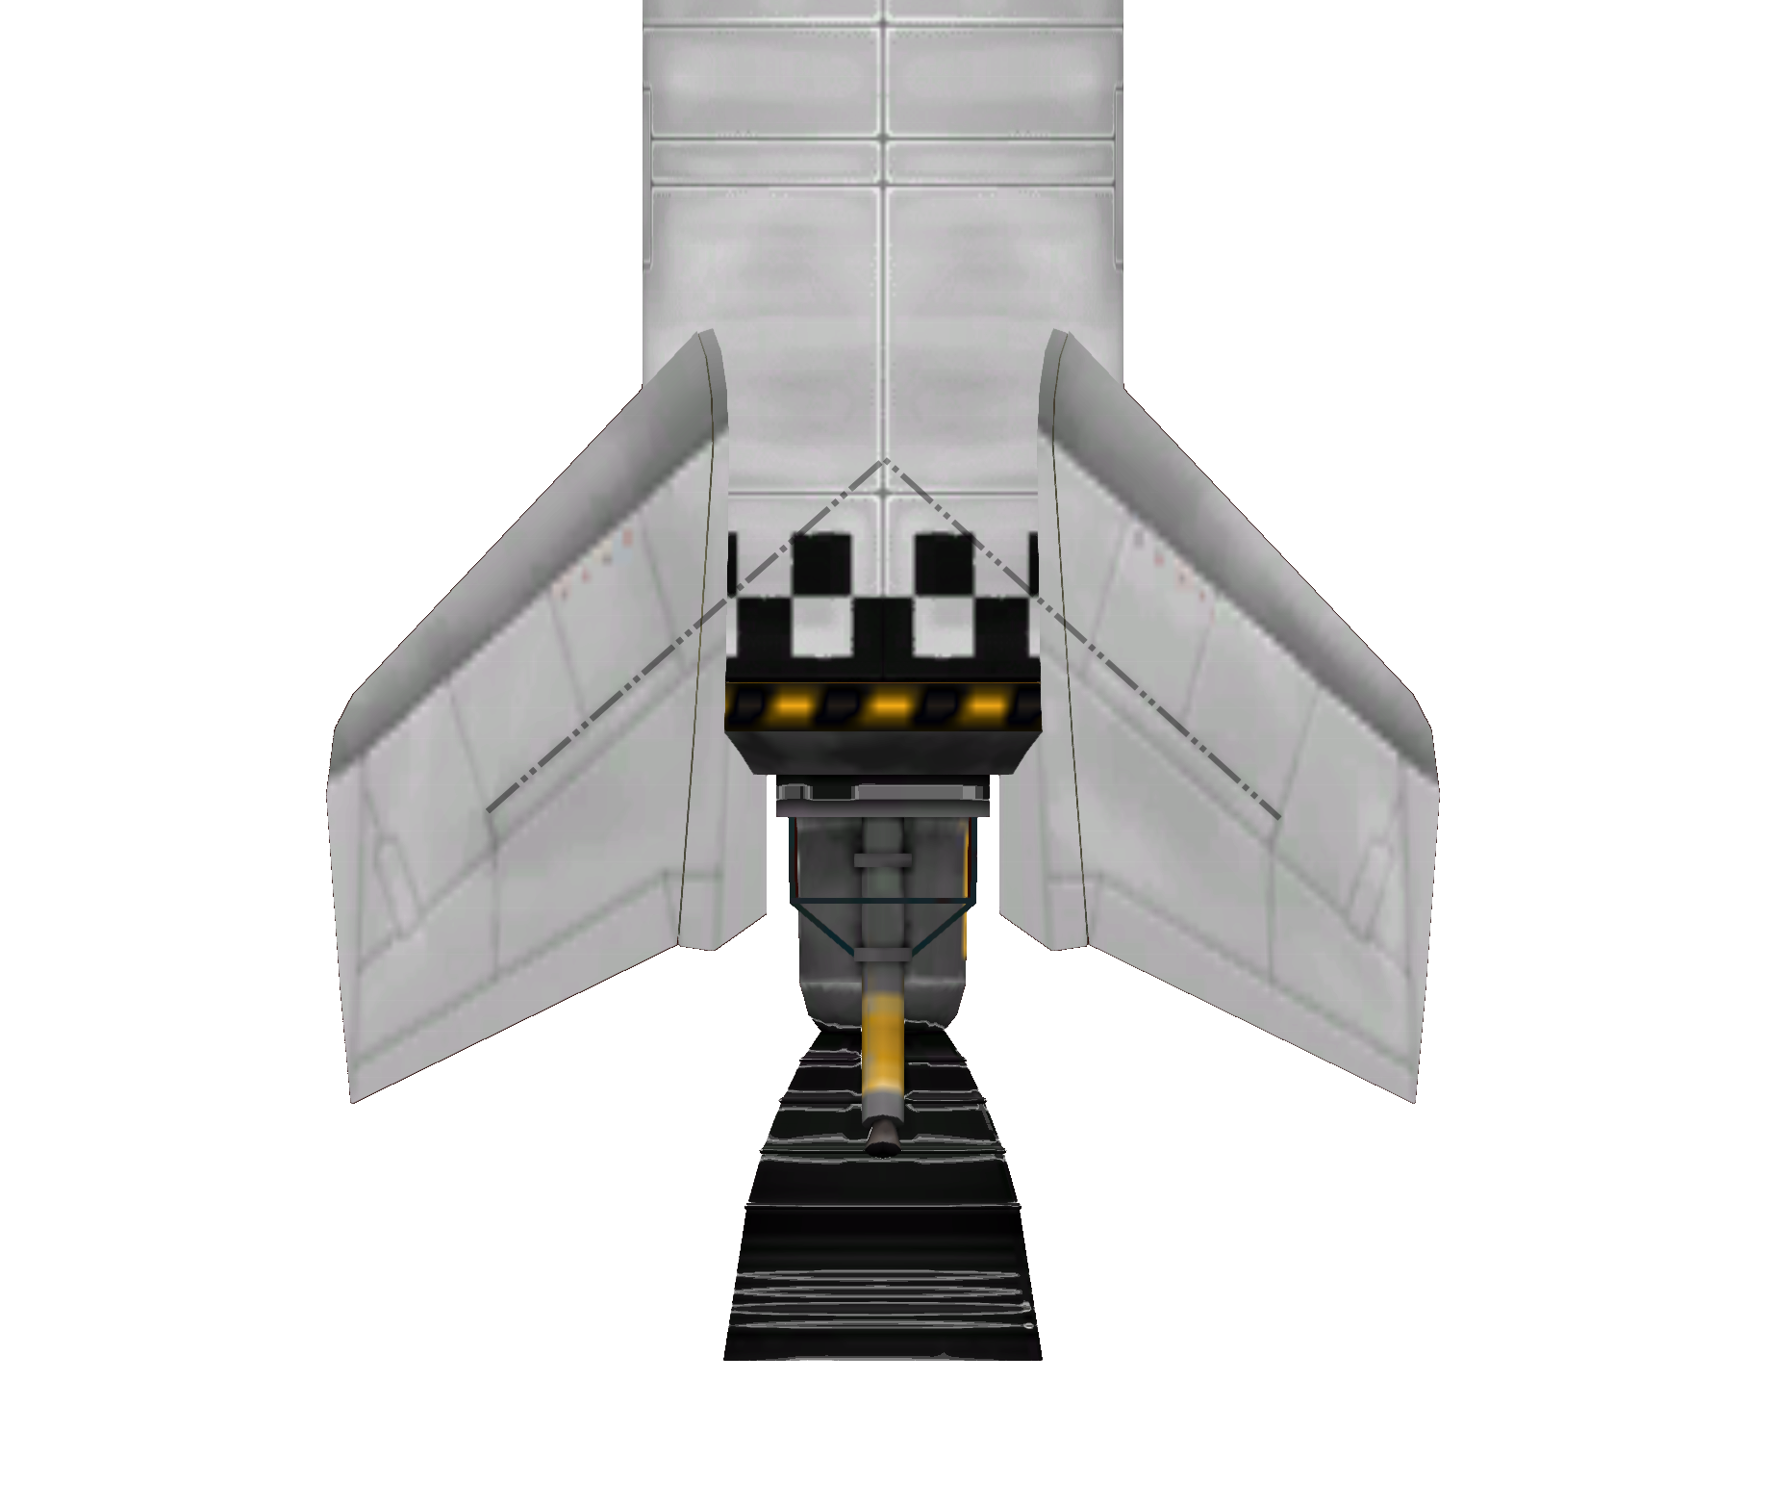
Illustration 1: High contrast picture of fin section, with reference extension line.
Under 4 way symmetry, take one AV-R8 Winglet. Using snap to position and 4 way symmetry, place four fins on a 45 degree angle to the Y and Z axes (cardinal directions NE, NW, SE and SW).
The fin height should be adjusted to match the picture to the right. As reference, when the fin position is correct, a line projecting from the short structural reinforcement above the middle full length one should intersect the first point (defined by the intersection of the square markings in the fuel tank) after the fin. The reference line should then intersect the top of the pattern, at the point between the one of the top-most squares that defined the first point, and the square immediately to the Z or Y axis.
Fins should be configured with a 30% control authority.

Booster decoupler installation
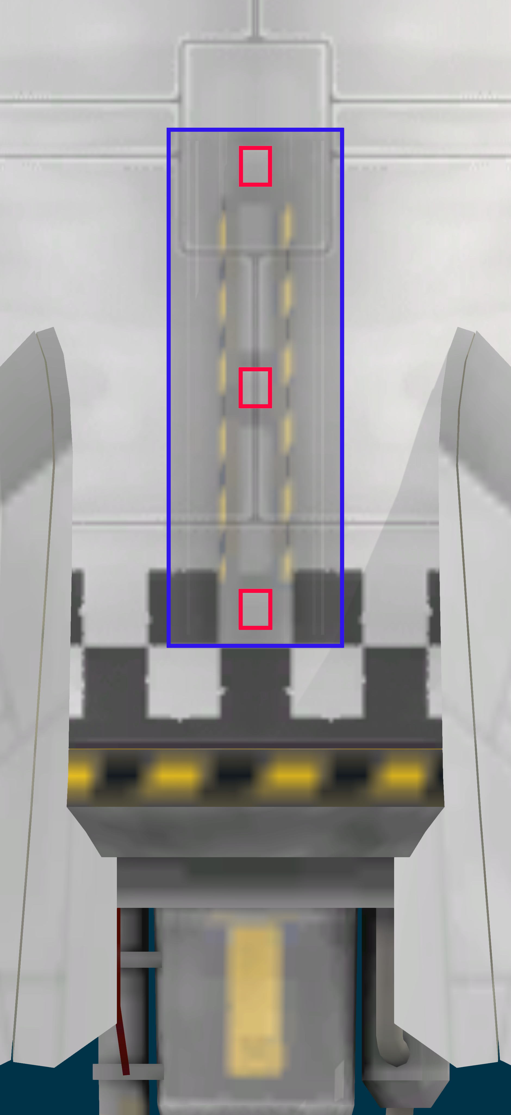
Illustration 2: Booster decoupler installation. Footprint highlighted in blue. Explosive bolts in red.
For boosted models, it is necessary to install radial decouplers that will act as support points for the boosters. The decouplers should be installed on the north and south sides using 2 way radial symmetry.
Using 2 way symmetry and angle snap, take a TT-38K radial decoupler and place over the north or south side. The decoupler should be mounted with the centre intersecting the plane defined by the X and Y axes. The FL-T400 tank has a seam in the position where the decoupler should be installed. This seam is interrupted at the top and bottom, as seen in the picture to the right.
Decoupler position along the rocket length can be easily determined by using the checker markings. The lower explosive bolt should be centred at the white square at the +-Y position.
Only R-3-1200 cores should be boosted. Boosting is not an option for R-3-400 and R-3-800 rockets.

B1 solid fueled booster installation
The B1 solid booster is built upon the RT-5 “Flea” solid rocket booster engine. The only other component is an aerodynamic nose cone.
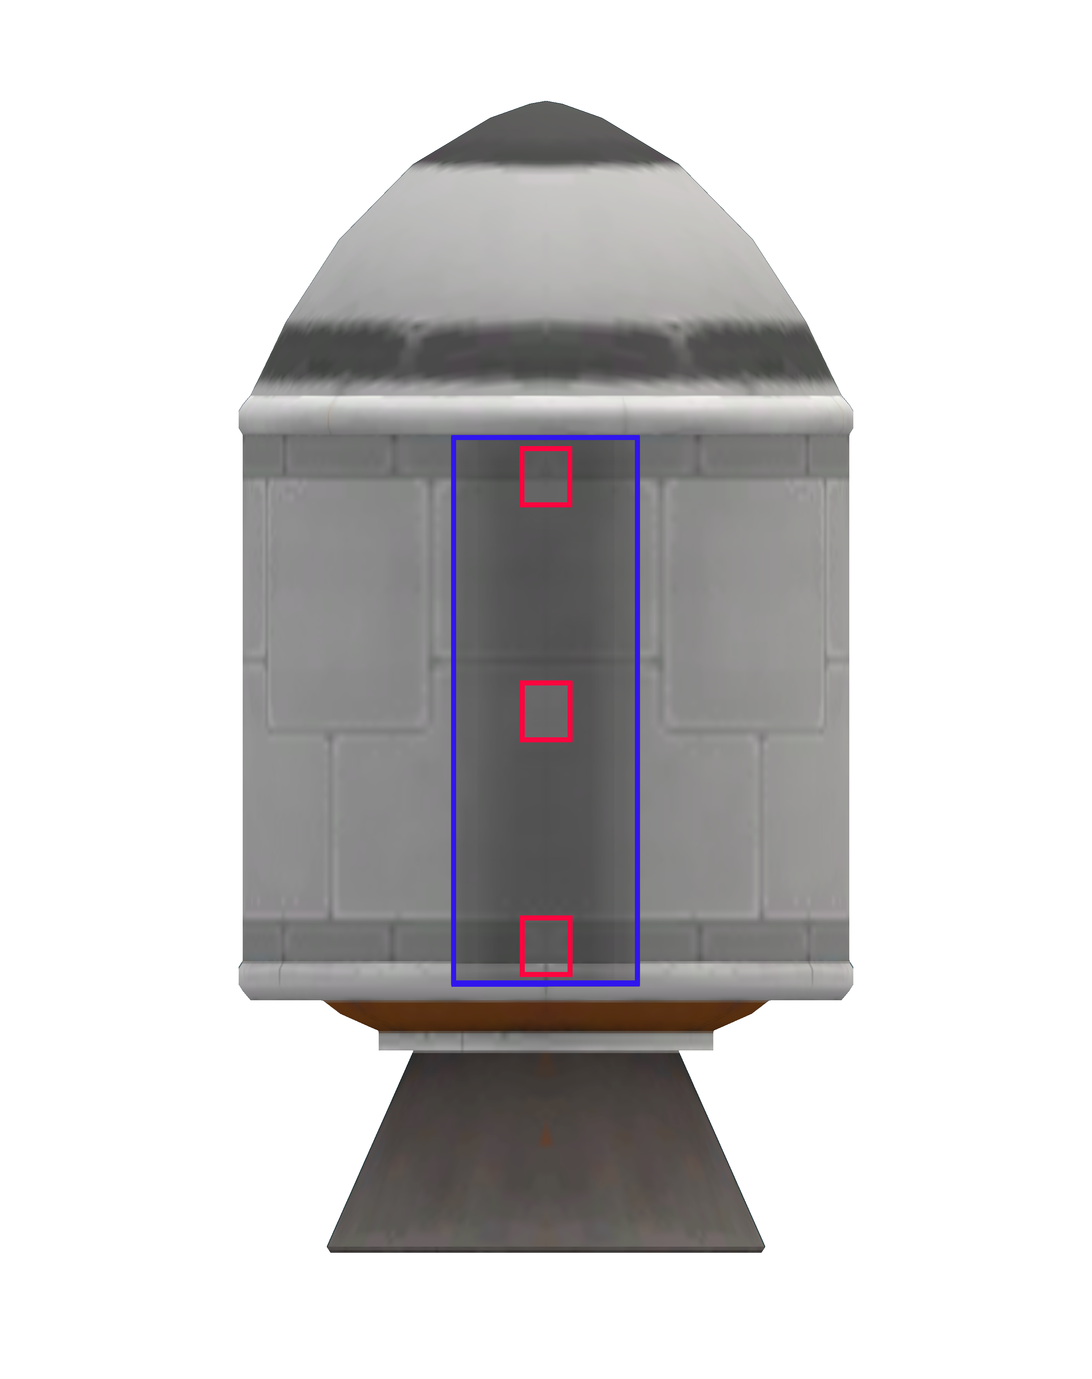
Illustration 3: B2 booster. Decoupler footprint in blue, explosive bolts in red.
Assembly is normally done by connecting a RT-5 solid engine to the lower stage decoupler. The decoupler should be installed over the full length of the fuel tank of the RT-5. The booster should be installed centred and the top of the decoupler should be over the grey line at the top of the fuel tank.
Once the booster is installed, the nose cone can be axially attached at the top.
The engine should then be configured to deliver 63% of the full thrust for use in the R-3 family.

L30-400 liquid fueled booster installation
The L30-400 booster is composed of a LV-T30 “Reliant” engine with a FL-T400 fuel tank and a basic nose cone on top. These components should be assembled axially.
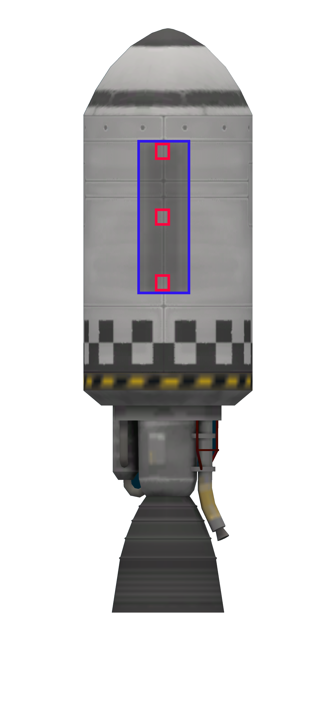
Illustration 4: L3-400 booster. Decoupler footprint in blue, explosive bolts in red.
To assemble a booster from individual components, connect a FL-T400 fuel tank to the lower stage decoupler. Immediately connect the nose cone and the engine to the fuel tank’s axial connectors.
Once the booster is assembled, move it along the radial decoupler until the top of the decoupler ends exactly at the riveted structure at the top of the tank (see picture to the right).
Once installed, set the engine thrust to 58% of maximum. This setting applies only to the R-3 family, other rockets may use a different configuration.

Upper stage
The R-3 family uses a single type of upper stage. This upper stage is powered by a LV-909 “Terrier” engine and fueled by a single FL-T400 liquid fuel tank.
The upper stage has 4 hardpoints in which additional equipment can be installed.

Upper stage core assembly
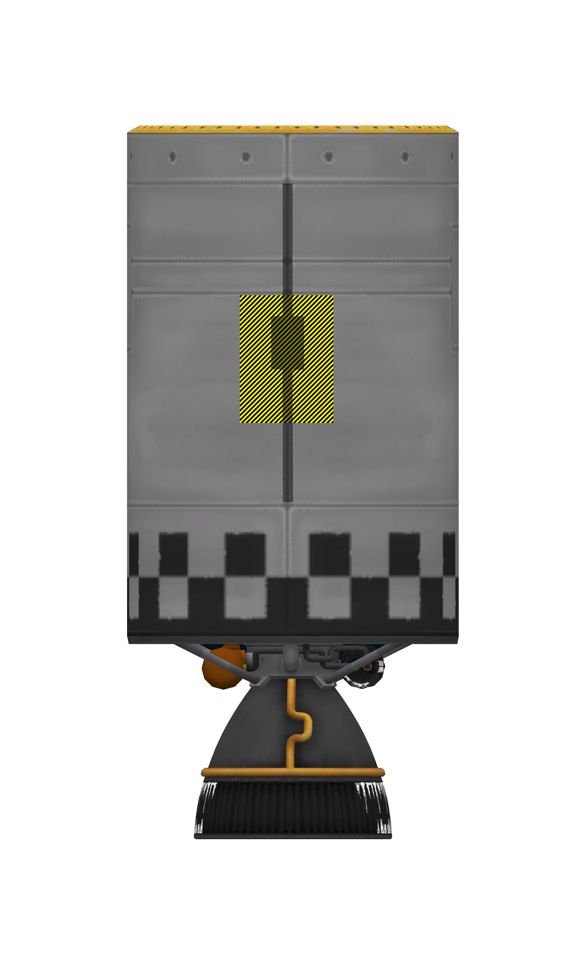
Illustration 5: Upper stage hardpoint, showing footprint for OX-STAT solar panel and Communotron 16-S antenna.
Upper stage core assembly is straightforward. Simply place a FL-T400 fuel tank over a Terrier engine axially. The engine should be set with a full thrust configuration.

Upper stage hardpoints
The upper stage has four hardpoints for external mounted avionics. The only external avionics currently available are the Communotron 16-S, OX-STAT solar panels and MechJeb’s AR202 case.
The communitron antenna should be mounted vertically, spanning the entire height of the three central panels. Its footprint is marked in black in the picture to the right.
The OX-STAT and AR-202 should be mounted immediately below the junction of the third to fourth panels, counted from the top, using the yellow footprint as a guide.
Both should be mounted using angle snap, with an orientation towards the cardinal points.
It should be noted that in the north and south faces of the rocket, the junction to be used as reference is partially interrupted by a square panel. The junction is present at the right and left sides of the hardpoint and should be used as a guide for mounting, ignoring the panel.

Payload section
Payload sections should be taken as-is from the KSS catalogued fairings.

LV type | Fairing | Mass | Uses
1 | A1 | 329 | General cargo, short fairing.
2 | A2 | 424 | General cargo, long fairing.
3 | A3 | 491 | General cargo, extra long fairing.
4 | B1 | 267 | AOC-3 launch.
5 | B2 | 323 | AOC-2 launch.

Cargo bays should also be configured as indicated in the fairings and cargo bay catalog. The following definitions are used in the R-3 family.

Cargo bay code | Description
F | Empty fairing, payload affixed to fairing base.
C | Capsule service module. Decoupler affixed to fairing base, capsule follows.
S | Single bay, as specified by fairing catalog.
D | Dual bay, as specified by fairing catalog.

Payload mass calculation
Payload mass should be corrected to account for the differences in avionics in each rocket model. Payload mass is calculated and tabled based on a baseline model (F1-N00N0X) and the following adjustments should be made for each variation.

Type | F | +0 Kg
Type | C | +40 Kg
Type | S | +40 Kg
Type | D | +80 Kg
Computer | N | +0 Kg
Computer | J | +0 Kg
Computer | O | +100 Kg
Computer | H | +100 Kg
Stabilization level | 0 | +0 Kg
Stabilization level | 1 | +50 Kg
Stabilization level | 2 | +100 Kg
Communications | 0 | +0 Kg
Communications | 1 | +15 Kg
Power generation | N | +0 Kg
Power generation | O | +10 Kg
Power generation | P | +5 Kg
Power generation | Q | +15 Kg
Power storage | 0 | +0 Kg
Power storage | 1 | +10 Kg
Power storage | 2 | +50 Kg
Recovery | X | +0 Kg
Recovery | R | +100 Kg

Example
A 500 Kg satellite is being launched in the single payload bay of an R3-1200-S1-H11O1X launcher rocket. The following adjustments should be applied to the payload mass.

Type S, single bay shrouded: add 40Kg to mass.
Type H computer: add 100Kg to mass.
Stabilization level 1: add 50Kg.
Level 1 communications: add 15Kg.
Battery level 1 (Z-200): add 10Kg
Dual solar panels (type O): add 10 Kg.
Expendable rocket: no mass added.

Total corrections: 225 Kg.

Adding 225 Kg to the payload mass of 500Kg yields a 725 Kg payload. It is expected that a R-1200-S1-H11O1X with a 500Kg payload will behave in a similar manner to a R3-1200-F1-N00N0X launcher carrying a 725 Kg payload.
This estimate only applies to internal cargo, and only with respect to and mostly applies to remaining delta V after launch. Components carried in upper stage hardpoints introduce a small drag penalty, and other flight characteristics are affected by the presence of the larger reaction wheel.

Base model mass table

Launch vehicle type | Empty mass (tonnes)
R3-400-F1-N00N0X | 7.019
R3-400-F2-N00N0X | 7.114
R3-400-F3-N00N0X | 7.181
R3-800-F1-N00N0X | 9.269
R3-800-F2-N00N0X | 9.364
R3-800-F3-N00N0X | 9.431
R3-1200-F1-N00N0X | 11.519
R3-1200-F2-N00N0X | 11.614
R3-1200-F3-N00N0X | 11.681
R3-1200B-F1-N00N0X | 14.629
R3-1200B-F2-N00N0X | 14.724
R3-1200B-F3-N00N0X | 14.791
R3-1200L-F1-N00N0X | 18.629
R3-1200L-F2-N00N0X | 18.724
R3-1200L-F3-N00N0X | 18.791

Mass table for flight tested hardware

Launch vehicle type | Mass
R3-400-S1-H01N1X | 7.184

Payload integration
Once the rocket is assembled, the payload should be integrated into the stack. Integration in its simplest for is just taking the payload (or payloads for dual launches) and attaching it to the payload bay decoupler.
The rocket comes with TD-12 payload decouplers. The couplers have a default position defined by in the payload catalog, but they may be changed as needed for each specific mission. However, using the predefined decoupler configurations help achieve a repeatable performance.
Weight saving measures can be implemented in the payload integration phase. These involve minor modifications to the payload interface with the rocket.
- Replacing the TD-12 decoupler with a TD-06 one, entails a reduction of 30Kg per replacement.
Payload decouplers may be replaced by separators, at a small mass penalty (10Kg per separator). Separators create debris during operation, and are not recommended for payload launches in orbit. If a separator is to be used, replace the upper bay decoupler with one, and readjust the lower bay decoupler’s ejection force to 100. Use of separators in the lower payload bays is not necessary, as recovery parachutes deploy through the lower separator by design.
For payload mass limits, see each the data pertaining each specific variant’s performance data. Payload volume data is available in the fairing catalog.

Ascent
Multiple ascent profiles are available, depending on the techniques available and the desired precision and ease of use.

MechJeb 2 ascent
MechJeb, if available, is the simplest ascent mode. It is also fully automated and may not be desirable in certain cases. MJ2 ascents achieve reasonably precise orbital insertions, achieving especially good results with respect to final orbital inclination. MJ2 ascents are somewhat imprecise for long circularisation burns.
To execute a MechJeb ascent, select the ascent program “Stock style gravity turn” and program the following parameters.
 | Parameter | Value
TARGET | Orbit altitude (Km) | 80
TARGET | Inclination (deg) | As required by mission parameters
GUIDANCE | Turn start altitude (Km) | 0.5
GUIDANCE | Turn start velocity (m/s) | 50
GUIDANCE | Turn start pitch | As indicated by rocket performance graph
GUIDANCE | Int. altitude (Km) | 80
GUIDANCE | Hold AP time (s) | 1
OPTIONS | Prev. engine ovrheat | No
OPTIONS | Limit Q (Pa) | No
OPTIONS | Limit Accel (m/s^2) | No
OPTIONS | Keep limited throttle (%) | No
OPTIONS | Electric limit (%) | No
OPTIONS | Force roll climb-turn | 90-90
OPTIONS | Limit AOA (deg) | 5
OPTIONS | Dynamic pres FO (Pa) | 2500
OPTIONS | Autostage | Yes
OPTIONS | Autostage delay, pre (s) | 0.5
OPTIONS | Autostage delay, post (s) | 1
OPTIONS | Clamp autostage thr (%) | 0.99
OPTIONS | Stg frings, dyn prs (KPa) | 5
OPTIONS | Stg frings, altitude (Km) | 50
OPTIONS | Stg frings, flux (W/m^2) | 1135
OPTIONS | Stop at stage | 1 for single  2 for dual
OPTIONS | Auto deploy solar panels | No
OPTIONS | Auto deploy antennas | No
OPTIONS | Auto warp | No
OPTIONS | Skip circularization | No

Other parameters should be left with their default values. All orbital and guidance parameters define how orbital insertion is done and should not differ from the data above.
The “stop at stage” parameter is set to exclude the payload staging. This is done to prevent premature ejection of inert payloads by MechJeb once the payload fairing is opened. If anything other than single stage payloads (e.g. payloads with kicker rockets) are placed in the payload bays, adjust the “stop at stage” value to one stage before the first payload decoupler (as a rule of hand, this is usually the stage number of the payload fairing).
The auto deploy options are set to false to prevent damage to the rocket and/or payload due to deployment inside the payload bay. This is especially true for lower payloads, and not critical for single or upper payloads. These switches may be toggled if it is determined that antenna and/or panel deployment will not interfere with proper operation of the spacecraft.
The initial gravity turn pitch should be decided taking the payload mass into account. For each payload mass, there should be an optimal angle, which minimizes propellant use. This angle has been recorded in performance data section. Next to this value are the 99% efficiency values. This values show the maximum and minimum angles that yield 99% of the delta V of the optimal angle. The outer values of the pitch angle table show the “never exceed” values. These are the hard limits of the gravity turn. Any attempted gravity turn that exceeds these values will likely cause the spacecraft to fail to orbit. Some of these failure modes are not correctable, and may not be immediately obvious.

SAS assisted ascent
SAS assisted launches are available for the case when MechJeb is unavailable or undesirable. This mode consists of doing a gravity turn, similar to Mechjeb’s, followed by a coast to apoapsis and circularisation burn.
SAS assisted ascents usually have a different pitch angle for optimum gravity turn performance, as it uses full pitch during the initial turn.
The ascent program for SAS assisted launches is shown below.
- Turn on SAS on stability assist mode
- Set throttles to 100%
- Activate the staging sequence to launch
- If necessary, rotate rocket so that the +Z side faces the desired orientation
  - This is usually done on the starboard side, which is already pointing to 090 degrees (due east)
  - For lower mass payloads and high TWR placing the launcher in an orientation different to the default may be necessary, if the roll cannot be completed before reaching turn velocity.
- Wait until speed relative to surface reaches 50 m/s
- Initiate a hard right turn, watch the velocity vector and wait until it reaches the desired angle
  - The winglets are calibrated as to prevent over-pitching when actuated at their maximum deflection
- When the velocity vector reaches the desired angle, set SAS to prograde mode
  - Alternatively, temporarily disable SAS and release controls to allow the winglets to passively stabilize the rocket. Activate prograde mode before activating the upper stage or at 10000 metres at latest.
- When propellants run out, activate the second stage, cutting thrust as soon as apoapsis reaches the desired altitude (usually 80 Km)
  - If apoapsis reaches the desired altitude before first stage cut-off, the climb was too steep. Consider aborting the mission or taking emergency action. Orbit may be achievable with light payloads. Consult the test data.
  - Alternatively, wait until apoapsis reaches 5km below intended orbit and reduce burn to minimum, adjusting altitude by actuating throttle during coast, if a single long burn is desired.
- Coast to apoapsis and wait until the tabled time for the current velocity, then set the throttle to 100%. Reduce throttle as apoapsis is pushed back. Try to keep the apoapsis time to close to 5 seconds. Do not pass apoapsis.
- Cut off upper stage engine when periapsis reaches intended altitude.
SAS ascent circularization table (80 Km orbit)
 |  | Orbital velocity
 |  | 1000 | 1250 | 1500 | 1750 | 2000 | 2250
Payload mass | 500
Payload mass | 1000
Payload mass | 1500
Payload mass | 2000
Payload mass | 2500
Payload mass | 3000
Payload mass | 3400

To use the table above, take the velocity as the upper stage reaches apoapsis and take the corrected payload mass (payload + avionics). Execute a full thrust prograde burn at the indicated number of seconds before apoapsis. Do not retard throttles until apoapsis is pushed away as orbital velocity is reached. Maintain the apoapsis time at the indicated number of seconds, increasing and decreasing throttle as necessary,

Hybrid ascent
The hybrid ascent combines the first part of the Mechjeb ascent with the circularization burn of the SAS ascent. This is particularly useful at the limits of Mechjeb ascent guidance capabilities. To execute a hybrid ascent follow the procedure below.
- Execute a MechJeb ascent until the Kerman line is reached.
- Disable MJ2 autopilot.
- Enable SAS prograde mode.
- If the payload fairing has not been ejected, eject it.
- Wait until the time for the circularisation burn is reached, and execute a SAS circulatisation.

Manual ascent
Manual ascent is identical to the SAS assisted burn with the following changes. This method is used when prograde mode is not available (e.g. with AR202 or OKTO computers).
- If SAS stabilization is available and used for turning, disable SAS after reaching the desired pitch.
- Let the fins stabilize the spacecraft until the first stage is jettisoned.
- Manually follow the prograde marker during second stage ascent, using any means available for that purpose.
- Once the apoapsis altitude nears the desired orbital altitude, throttle down and continue burn with reduced power until the apoapsis reaches the desired orbital altitude.
- Execute a SAS-style circularization burn.

Payload ejection
Payload ejection for single launches should follow the standard procedure. Payloads are ejected using a decoupler, which applies a separation force. This applies to upper payloads in dual launches.
The lower payload of a dual launcher utilizes a zero ejection decoupler system and must be maneuvered out of the payload bay. There are several approved procedures.
- If the payload has RCS, apply a lateral translation burst to move it from the payload bay.
- If the payload has no RCS, but reaction wheels and a station keeping engine, rotate payload and apply thrust to clear the payload bay. Payload may bump into upper bay or lower bay supports.
- If payload engine fails, rotate the rocket after decoupling using the rocket’s reaction wheels (if available).
Bumping the payload bays during payload rotation may induce translation that could get a payload out of the bay, but this should be regarded as an emergency procedure only. Damage to payload or carrier rocket may occur if this procedure is used.
C type models are used as capsule service modules and should not normally be decoupled from the payload, as the capsule may need the module for propulsion. Ejection of C type upper stages are normally done after the final reentry burn. Read the capsule manufacturer’s documentation for the recommended procedure.

Deorbit burn
Most variants of the R-3 rocket have a flight computer and a small amount of battery capacity (or solar panels) to permit deorbiting of the spent upper stage once payloads are delivered. The procedure varies depending on the avionics and control systems available.
Deorbit procedures should commence as soon as the payload is released. Basic models have a AR202 computer with limited (5 unit) battery capacity. More advanced models have solar panels and larger batteries that extend the useful life of the rocket, allowing the execution of the deorbit burn at later, more convenient, times.

Combination deorbiting and inclination change
If the mission involves delivering payloads to a highly elliptic orbit with an inclination change, the burn may be executed at the node after periapsis, trading inclination for periapsis altitude. This type of burns leaves the payload in a suborbital trajectory, which requires the payload to complete its insertion burn at apoapsis or risk reentry.

Direct deorbiting
The usual mode of operation consists of executing a deorbit burn after delivering a payload to a circular low Kerbin orbit or elliptic orbit. This requires the rocket to turn to retrograde orientation and execute a burn using the remaining propellants.
The method of executing the turn depends on the control systems available. For models with reaction wheels, or OKTO and HECS computers the procedure consists of turning to retrograde using the wheels. Then, the engine can be fired.
For AR202 equipped models without wheels, rotation can be induced by steering the rocket (actuating the gimbals on the Terrier engine) and pulsing the engine once. Once the engine is about to pass the retrograde orientation, it can be fired to deorbit the rocket.

Sub orbital insertion
For payloads with a mass above, but close to, the rocket’s maximum payload, an incomplete orbital insertion may be executed. In this insertion profile, the rocket is burned until fuel exhaustion without reaching LKO, ideally with a periapsis altitude between 65 to 70 KM. The final insertion burn is executed by the payload’s apoapsis kicker motor. The rocket is left to reenter the atmosphere. This mode allows the use of a rocket without an onboard computer, while preventing the creation of debris in orbit and allowing parachute recovery of the upper stage at the same time.

Flight profiles

KSC operations
KSC launches are limited from 73 degrees to 212 degrees to avoid launching over populated areas.

Equatorial orbital injection
The equatorial orbital injection is a launch due east. It is used for orbiting various types of payloads, for trans-munar payloads, for injection kerbisynchorous equatorial transfer orbit or for direct interplanetary transfers.
Parameter | Value
Launch azimuth | 090 (east)
Inclination | 0 (prograde)
Altitude | 80 KM
Eccentricity | 0 (circular)

Polar orbital injection
The polar orbital injection profile is a southbound launch used to insert payloads into polar LKO. Transfer to higher orbits is possible after orbital insertion.
Parameter | Value
Launch azimuth | 184 (roughly south)
Inclination | 90 (polar)
Altitude | 80 KM
Eccentricity | 0 (circular)

Requires MechJeb plugin to work.
P and Q power systems are not compatible with J type computers.
Assumes single payload with no additional staging in each bay. Fully read this section and adjust properly if that is not the case.
Defined as 70Km over Kerbin surface. https://en.wikipedia.org/wiki/K%C3%A1rm%C3%A1n_line

